Software Requirements Specification

for

HawkerHub

**Version 1.1.0 approved**

**Prepared by**

Akshay Krishna U2220599B

Arif Yusaf Ansari U2222715K

Chester Yee U2221891B

Chua Shun Kah U2222915D

Clarence Tan Wen Yang U2222384F

Keith Ang Kee Chun U2220349G

**SDAC Team 1, FireNinjas**

**03 November 2023**

**Table of Contents**

**1. Introduction 6**

1.1 Purpose 6

**1.2 Document Conventions 6**

**1.3 Intended Audience and Reading Suggestions 6**

**1.4 Product Scope 7**

**1.5 References 7**

**2. Overall Description 8**

2.1 Product Perspective 8

**2.2 Product Functions 8**

2.2.1 Accounts 8

2.2.2 Main 8

**2.3 User Classes and Characteristics 9**

2.3.1 Hawker Centre Customers 9

2.3.1 Tourists 9

**2.4 Operating Environment 10**

2.4.1 Production Environment of HawkerHub 10

2.4.2 Development Environment of HawkerHub 10

**2.5 Design and Implementation Constraints 12**

2.5.1 Limitations 12

2.5.2 Design Standards 12

2.5.3 Regulatory compliance 12

**2.6 User Documentation 13**

**2.7 Assumptions and Dependencies 13**

2.7.1 Third party APIs 13

2.7.2 User Internet Connectivity 13

2.7.3 OpenAI API 13

2.7.4 Google Places API 13

2.7.5 Data.gov API 13

2.7.6 Supabase DB 13

2.7.7 Mapbox 13

**3. External Interface Requirements 14**

3.1 User Interfaces 14

3.1.1 Home Page 15

3.1.2 HawkerList Page 16

3.1.3 HawkerDetail Page 17

3.1.4 Login Page 19

3.1.5 Email 20

3.1.6 Profile Page 20

3.1.7 Updated Profile Page 21

3.1.8 HawkerList Page – Favorited 22

**3.2 Hardware Interfaces 23**

3.2.1 Client-side Requirements 23

3.2.2 Server-side Requirements 23

**3.3 Software Interfaces 23**

3.3.1 Software Components and Versions 23

3.3.2 Software Architecture 23

**3.4 Communications Interfaces 24**

**4. System Features 25**

**4.1 Login to Application 25**

4.1.1 Description and Priority 25

4.1.2 Stimulus/Response Sequences 25

4.1.3 Functional Requirements 26

4.2 Create Account 26

4.2.1 Description and Priority 26

4.2.2 Stimulus/Response Sequences 26

4.2.3 Functional Requirements 26

4.3 View Hawker Centres List 27

4.3.1 Description and Priority 27

4.3.2 Stimulus/Response Sequences 27

4.3.3 Functional Requirements 27

4.4 Search for Hawker Centres 28

4.4.1 Description and Priority 28

4.4.2 Stimulus/Response Sequences 28

4.4.3 Functional Requirements 28

4.5 View Map 29

4.5.1 Description and Priority 29

4.5.2 Stimulus/Response Sequences 29

4.5.3 Functional Requirements 29

4.6 View Maintenance Table 30

4.6.1 Description and Priority 30

4.6.2 Stimulus/Response Sequences 30

4.6.3 Functional Requirements 30

4.7 Manage Favourite Hawker Centers 31

4.7.1 Description and Priority 31

4.7.2 Stimulus/Response Sequences 31

4.7.3 Functional Requirements 31

4.8 View Favorited Hawker Centres 32

4.8.1 Description and Priority 32

4.8.2 Stimulus/Response Sequences 32

4.8.3 Functional Requirements 32

4.9 Upcoming Maintenance Notification 33

4.9.1 Description and Priority 33

4.9.2 Stimulus/Response Sequences 33

4.9.3 Functional Requirements 33

4.10 View Hawker Details 34

4.10.1 Description and Priority 34

4.10.2 Stimulus/Response Sequences 34

4.10.3 Functional Requirements 34

4.11 View Nearby Hawker Centres 35

4.11.1 Description and Priority 35

4.11.2 Stimulus/Response Sequences 35

4.11.3 Functional Requirements 35

4.12 Update Account Details 36

4.12.1 Description and Priority 36

4.12.2 Stimulus/Response Sequences 36

4.12.3 Functional Requirements 36

4.13 View Account 37

4.13.1 Description and Priority 37

4.13.2 Stimulus/Response Sequences 37

4.13.3 Functional Requirements 37

**5. Other Nonfunctional Requirements 38**

5.1 Performance Requirements 38

**5.2 Safety Requirements 38**

**5.3 Security Requirements 38**

**5.4 Software Quality Attributes - clarence 38**

5.4.1 Availability 38

5.4.2 Adaptability 38

5.4.3 Maintainability 38

5.4.4 Portability 38

5.4.5 Reliability 38

5.4.6 Reusability 39

5.4.7 Testability 39

5.4.8 Robustness 39

5.4.9 Usability 39

**5.5 Business Rules 39**

5.5.1 User authentication 39

5.5.2 Favourite hawker centres 39

5.5.3 Update account 39

5.5.4 Maintenance table 40

5.5.6 Notification preference 40

5.5.7 Magic link authentication 40

5.5.8 Nearby hawker centres 40

5.5.9 View list of hawker centres 40

5.5.10 View map 40

5.5.11 View hawker centre details 40

**6. Other Requirements 41**

Appendix A: Data Dictionary 41

Appendix B: Analysis Models 43

**Revision History**

| **Name** | **Date** | **Reason For Changes** | **Version** |
| --- | --- | --- | --- |
| Keith Ang Kee Chun | 03/11/2023 | Initial Documentation | 1.0.0 |
| Arif Yusaf Ansari | 05/11/2023 | System Features | 1.0.1 |
| Akshay Krishna | 07/112023 | Overall Description | 1.0.2 |
| Chua Shun Kah | 08/11/2023 | Analysis Models - System Arch | 1.0.3 |
| Chester Yee | 10/11/2023 | Refinements and correction of phrasing | 1.1.0 |
|  |  |  |  |

# Introduction

## Purpose

This Software Requirement Specification (SRS) document is intended for the HawkerHub web application, build version 1.0. The purpose of this SRS document is to describe the requirements specifications for the HawkerHub web application to facilitate the development and production process for all stakeholders. All aspects of the web application, which includes but not limited to, the system features, the limitations, the non-functional and interface requirements, are documented within this SRS document.

## Document Conventions

This section describes the conventional standards used throughout this document. It is imperative that all readers pay attention to the standards listed in this section.

* Font: Arial
* Heading 1: Size 18
* Heading 2: Size 14
* Heading 3: Size 12
* Normal Text: Size 11
* Technical Standards: IEEE 830-1998

Refer Appendix A: Data Dictionary for the definitions of special terms used throughout this documentation.

## Intended Audience and Reading Suggestions

This document is intended for all stakeholders, which include the users of HawkerHub web application, the HawkerHub development team, the HawkerHub testing team, the project managers and the HawkerHub marketing team.

This document begins by stating the purpose of the web application and several conventions used throughout the document. Next, a high-level overview of the application functionalities is introduced, followed by several design constraints and assumptions of the application. Then, the interface requirements of the application are stated. Finally, the document includes a detailed write-up of the system features and non-functional requirements of the application.

All stakeholders are advised to begin by reading section 1.1 Purpose, 1.2 Document Conventions and Appendix A: Data Dictionary to be familiarised with the purpose of the web application, as well as the documentation standards and technical terms definition used throughout this document.

The HawkerHub development team is strongly encouraged to proceed with section 2. Overall Description to have a high-level understanding of the application functionalities, design, and constraints. Then, section 4. System Features follows, where the developers will gain a low-level understanding of each system features to be included in the application. Finally, the developers should read section 3. External Interfaces Requirements and 5. Other Nonfunctional Requirements to understand the requirements specified for the application to function as desired.

On the other hand, the users of HawkerHub web application, the HawkerHub testing team, the project managers and the HawkerHub marketing team are encouraged to proceed reading this document in sequential order.

## Product Scope

With the rise of hawker culture during COVID-19, the vibrant and diverse culinary scene in Singapore not only persevered but adapted to the challenges posed by the global pandemic. The COVID-19 outbreak prompted a reevaluation of traditional dining practices, leading to a surge in innovative approaches within the hawker culture. Amidst lockdowns and social distancing measures, many hawker stalls pivoted towards online platforms, offering delivery and takeaway services. This digital transformation allowed the hawker culture to reach a broader audience, ensuring that people could continue to enjoy their favourite local dishes while adhering to safety guidelines.

HawkerHub is a web application that will help users navigate and explore the rich landscape of hawker culture in Singapore seamlessly. Developed in response to the evolving needs of food enthusiasts, HawkerHub serves as a comprehensive platform designed to enhance the hawker experience. The application also integrates real-time information, ensuring that users have access to the latest updates on stall opening and reviews. With a built-in map feature, HawkerHub assists users in locating nearby hawker centres and stalls, streamlining the decision-making process when hunger strikes.

As HawkerHub becomes an integral part of the hawker culture ecosystem, it not only transforms the way people engage with their favourite stalls but also contributes to the preservation and promotion of Singapore's culinary heritage. In a rapidly changing world, this innovative platform ensures that the vibrancy and diversity of hawker culture remain accessible, celebrated, and enjoyed by all.

## References

Docs: Next.js. (2023). https://nextjs.org/docs

Supabase. (2023, November 10). *Supabase documentation*. Supabase Docs. https://supabase.com/docs

*OpenAI platform*. OpenAI Platform. (n.d.). https://platform.openai.com/docs/api-reference

Google. (n.d.). Google. https://developers.google.com/maps/documentation/places/web-service/overview

# Overall Description

## Product Perspective

HawkerHub is a new, standalone and self-contained web application that aims to revolutionise the way people discover, access, and interact with hawker food stalls and markets. It shows users the closure dates of all hawker centres in Singapore and other relevant information that will enhance their overall hawker experience. The application's commitment to user convenience and engagement extends beyond its intuitive interface, encompassing a variety of features to ensure a seamless and enjoyable exploration of Singapore's hawker culture.

## Product Functions

The HawkerHub web application’s system features can be broken down into two main subcategories — Accounts and Main. This section provides a high-level view of the system features provided by the web application. Specifics regarding each feature, such as the activity flows, conditions, assumptions, and functional requirements achieved can be found under section 4. System Features.

### 2.2.1 Accounts

1. Account Creation
2. Account Login
3. Updating Account Details
4. View Account

### 2.2.2 Main

1. The application allows users to View Hawker Centres List
2. The application allows users to Search for Hawker Centres
3. The application allows users to View Map of Hawker Centres
4. The application allows users to View Upcoming Maintenance Table
5. The application allows users to Manage Favourite Hawker Centers
6. The application allows users to View Favorited Hawker Centres
7. The application prompts users about Upcoming Maintenance
8. The application allows users to View Hawker details
9. The application allows users to View Nearby Hawker Centres

## User Classes and Characteristics

The HawkerHub web application anticipates its demographic audience to be the following, ranked by the order of importance:

### 2.3.1 Hawker Centre Customers

| **Attributes** | **Description** |
| --- | --- |
| Frequency of use | High |
| Subset of functions used | 1. Account Creation 2. Account Login 3. Updating Account Details 4. View Account 5. View Hawker Centres List 6. Search for Hawker Centres 7. View Map of Hawker Centres 8. View Upcoming Maintenance Table 9. Manage Favourite Hawker Centres 10. View Favorited Hawker Centres 11. Upcoming Maintenance Notifications 12. View Hawker details 13. View Nearby Hawker Centres |
| Technical Expertise | Low |
| Characteristics | Users of this demographic will use the web application to make informed decisions by being notified of any upcoming maintenance of their hawker centre of choice |

### 2.3.1 Tourists

| **Attributes** | **Description** |
| --- | --- |
| Frequency of use | Medium |
| Subset of functions used | 1. Account Creation 2. Account Login 3. Updating Account Details 4. View Account 5. View Hawker Centres List 6. Search for Hawker Centres 7. View Map of Hawker Centres 8. View Upcoming Maintenance Table 9. Manage Favourite Hawker Centres 10. View Favorited Hawker Centres 11. Upcoming Maintenance Notifications 12. View Hawker details 13. View Nearby Hawker Centres |
| Technical Expertise | Low |
| Characteristics | Users of this demographic will use the web application to explore and plan their trips around Singapore to enjoy the different local cuisines in the different areas that have hawker centres. |

## Operating Environment

HawkerHub is designed with a mobile first approach and runs on devices with a web browser.. It should operate on both Android and iOS platforms. HawkerHub should be compatible with Android OS versions starting from Android 6.0 (Marshmallow) and later. For iOS devices, HawkerHub should be compatible with iOS versions starting from iOS 10 and later.

HawkerHub relies on internet connectivity for all of its features and it should be able to function seamlessly over Wi-Fi and mobile data (3G, 4G, 5G) to ensure users can access its services.

HawkerHub requires access to the device’s location services to provide accurate recommendations nearby the user’s current location.

HawkerHub adopts a responsive design and can be viewed on different viewports to provide a consistent and user-friendly experience agnostic to any device.

### 2.4.1 Production Environment of HawkerHub

| **Support** | **Description** |
| --- | --- |
| HTML | * The web application requires an internet browser which supports at least HTML5 or above * Note that HTML5 is the latest standard of HTML at the time of writing this documentation |
| CSS | * The web application requires an internet browser which supports at least CSS3 or above * Note that CSS3 is the latest standard of CSS at the time of writing this documentation |
| JavaScript | * The web application requires an internet browser which supports JavaScript |

### 

### 2.4.2 Development Environment of HawkerHub

| **Support** | **Description** |
| --- | --- |
| Next.js | * Next.js is an open-source React framework for building modern web applications. It is a popular choice for building user interfaces for web applications due to its component-based architecture, which allows developers to create reusable components that can be used across multiple pages and applications. Next.js also provides a set of conventions and features that simplify the development process, making it a popular choice for building both static and dynamic websites and web applications. * The HawkerHub development team uses Next.js to build all user interfaces of the web application as it features reusable components which can drastically speed-up the development process to produce a Minimum Viable Product (MVP) * Next.js v13.5.5 is used |
| Supabase | * Supabase is an open-source platform that provides developers with a set of tools and services to build and scale applications with ease. It combines the functionalities of a database, authentication system, and real-time features, offering a comprehensive solution for building modern web and mobile applications * Supabase uses PostgreSQL as its underlying database engine with powerful query capabilities * Supabase provides user authentication out of the box and developers can easily integrate authentication features, such as user registration, login, and password recovery, into our applications * Supabase v0.23.08 is used |

## Design and Implementation Constraints

This section covers all constraints which have limited, or will be limiting, options available to the HawkerHub development team, both during development stage and post-production maintenance stage. Additionally, this section also documents all design standards of the web application.

### 2.5.1 Limitations

Covers all limitations which may or may not affect certain functionalities of the HawkerHub.

| **Limitation** | **Description** |
| --- | --- |
| Cloud Service Provider | * Supabase offers a generous free tier, but as the application grows, more demand is to be expected and the cost can become significant. Some developers may find that the pricing structure not ideal for their needs especially when they’re working on a tight budget * Limited number of API calls over a certain period of time |

### 2.5.2 Design Standards

Covers all design standards adopted by HawkerHub

| **Conventions** | **Description** |
| --- | --- |
| Programming | * All non-class variables and functions must adopt the camelCase naming convention * All class variables must adopt the Pascal Case naming convention |
| User Interface | * Design and colour scheme must adhere to stakeholder’s requirement * Responsive so as to ensure usability on a variety of devices such as smartphones and tablets with different viewports |

### 2.5.3 Regulatory compliance

Web applications must adhere to data protection and privacy regulations, which includes local and international standards such as GDPR (General Data Protection Regulation).

## User Documentation

HawkerHub is designed to be user-friendly and intuitive. We aim to provide a straightforward experience without the need for user manuals or guides. The user interface is crafted to be easily navigable, and features are implemented with ease of use in mind.

## Assumptions and Dependencies

### 2.7.1 Third party APIs

Assumption: Availability and functionality of third-party APIs will remain serviceable and meet the needs of HawkerHub

Implication: Distributions to these APIs may affect the features and functionalities that depend on them

### 2.7.2 User Internet Connectivity

Assumption: Users must have stable and reliable internet connection

Implication: Unreliable internection connectivity will impact user’s ability to use the web application effectively

### 2.7.3 OpenAI API

Dependency: Web application integrates OpenAI API in order to analyse reviews to obtain sentiment analysis

Implication: Changes or disruption to OpenAI API may affect sentiment analysis feature

### 2.7.4 Google Places API

Dependency: Web application relies on Google Places API to obtain information about hawker centres such as address, contact details, and user reviews

Implication: Changes or disruption to Google Places API may affect the completeness and accuracy of hawker centre details

### 2.7.5 Data.gov API

Dependency: Web application relies on Data.gov (Dates of Hawker Closure API) to obtain information about when hawker centres will be closed for maintenance

Implication: Changes or disruption to Data.gov (Dates of Hawker Closure API) may affect information regarding the closure dates of all hawker centres

### 2.7.6 Supabase DB

Dependency: Web application relies on Supabase DB to store and retrieve user related data

Implication: Changes or disruption to Supabase DB may affect the web application’s data management and retrieval functionalities

### 

### 2.7.7 Mapbox

Dependency: Web application integrates Mapbox for mapping and geological services (eg. finding nearby hawker centres within 2km radius)

Implication: Changes or disruption to Mapbox may affect web application’s mapping features and the ability to locate and provide information about nearby hawker centres

# External Interface Requirements

## User Interfaces

HawkerHub is designed to be responsive and adaptable to different viewports on different devices. On top of that, the browser must satisfy the requirements as indicated within section 2.4.1 Production Environment of HawkerHub.

### Home Page

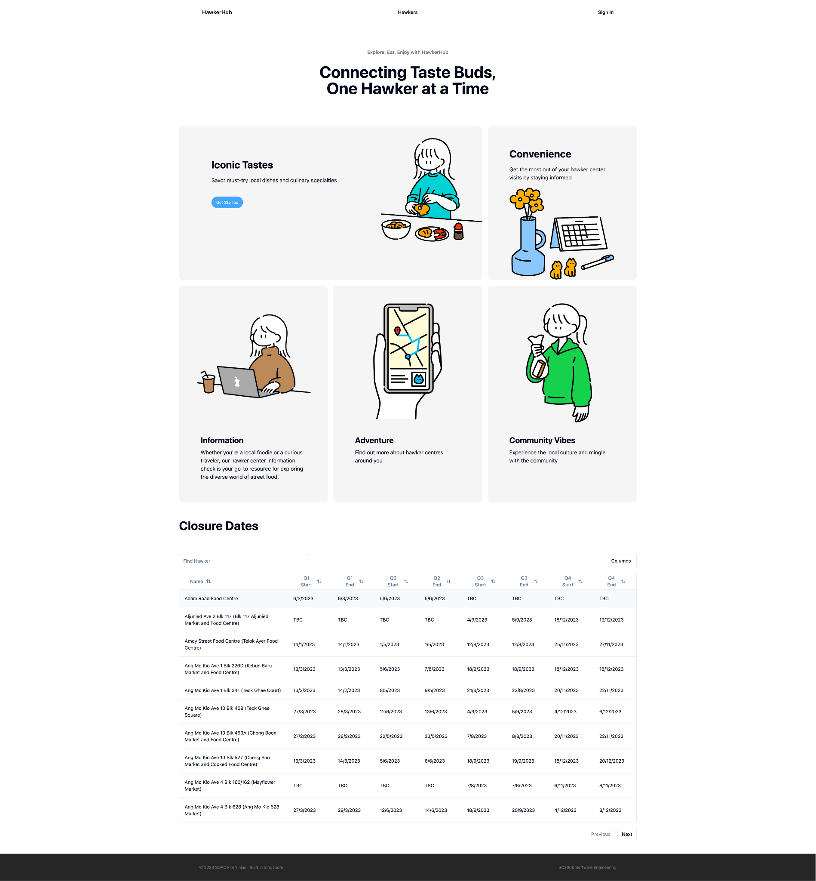

### 

### HawkerList Page

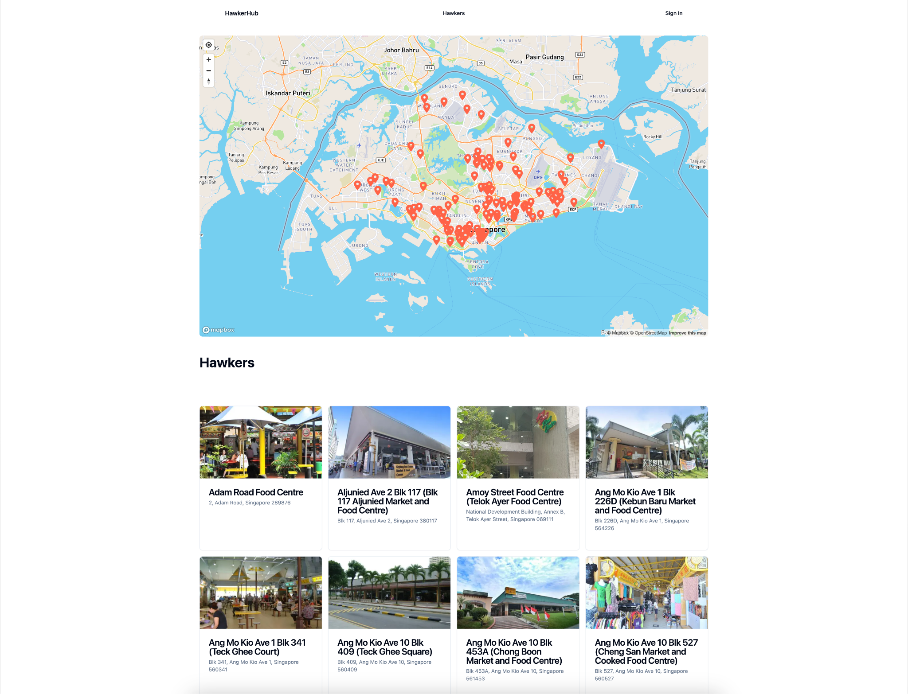

### 

### 

### HawkerDetail Page

### Without Error

Number of days to next closure is shown

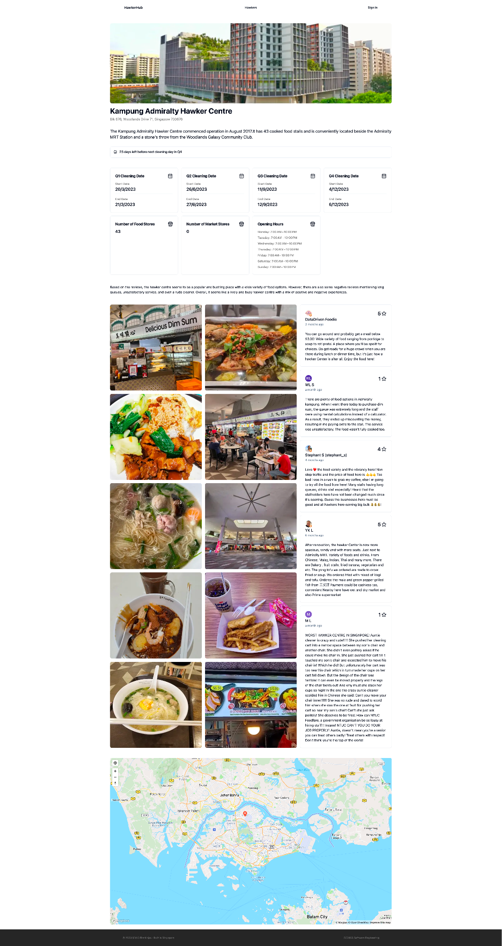

With error

Alternative message is shown when closure dates are all over or “TBC” as retrieved

### 

### Login Page

Regex is used here to catch any input formatting discrepancy

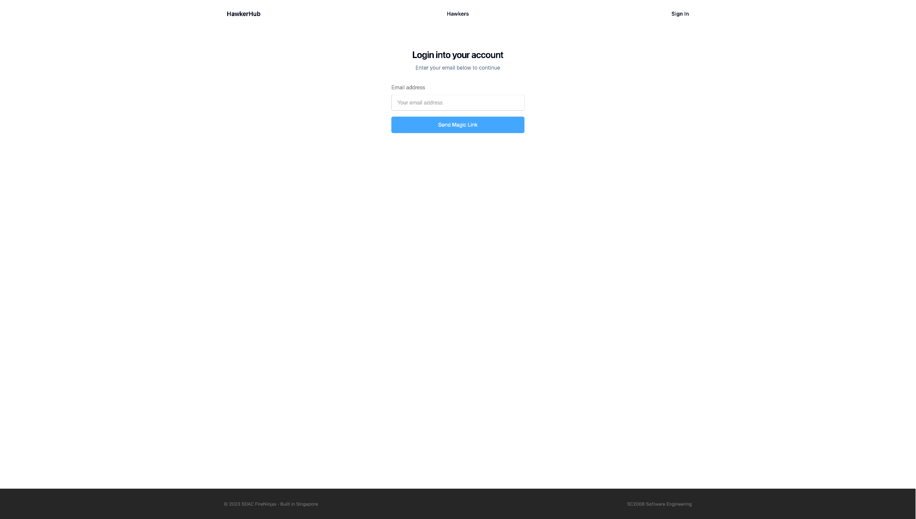

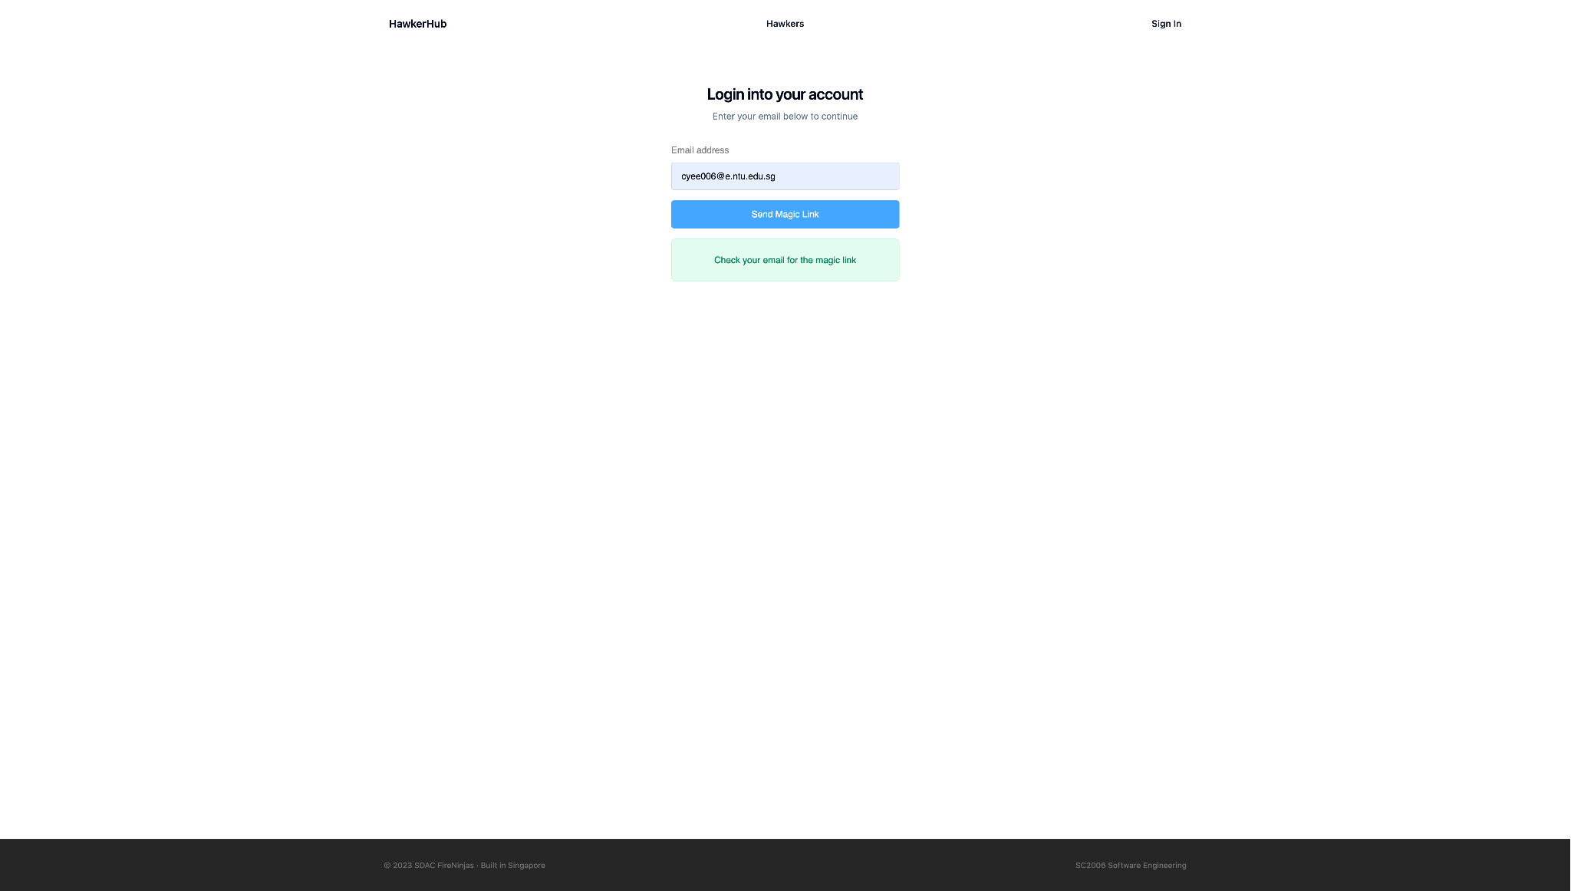

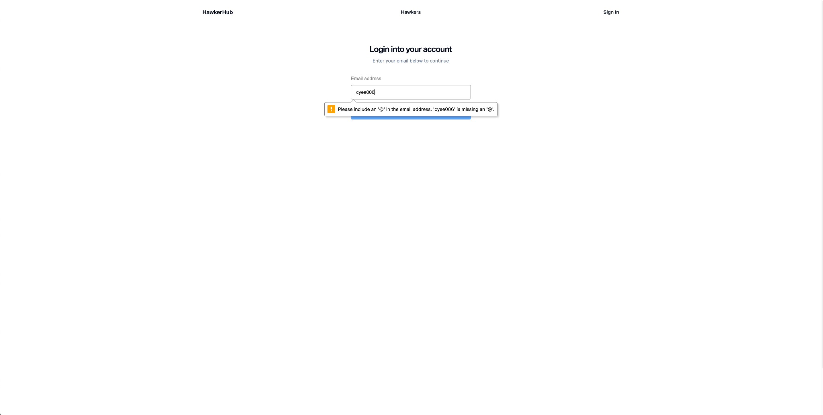

### Email

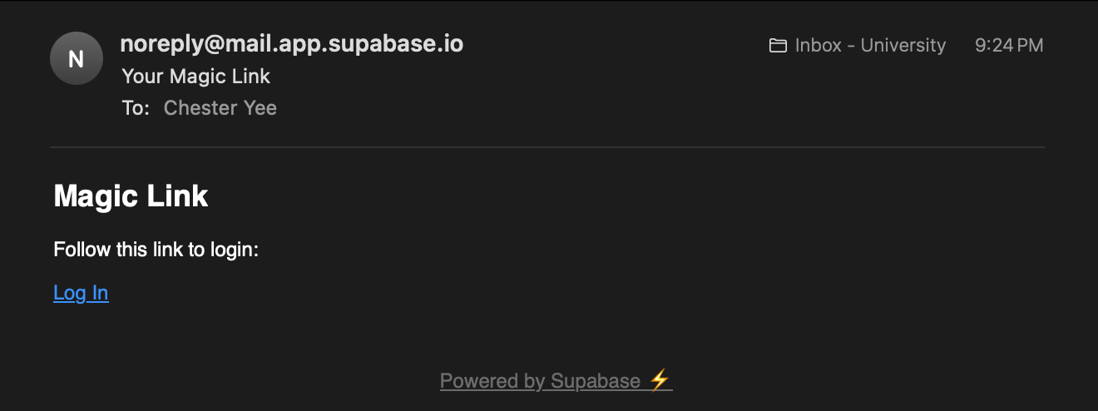

### Profile Page

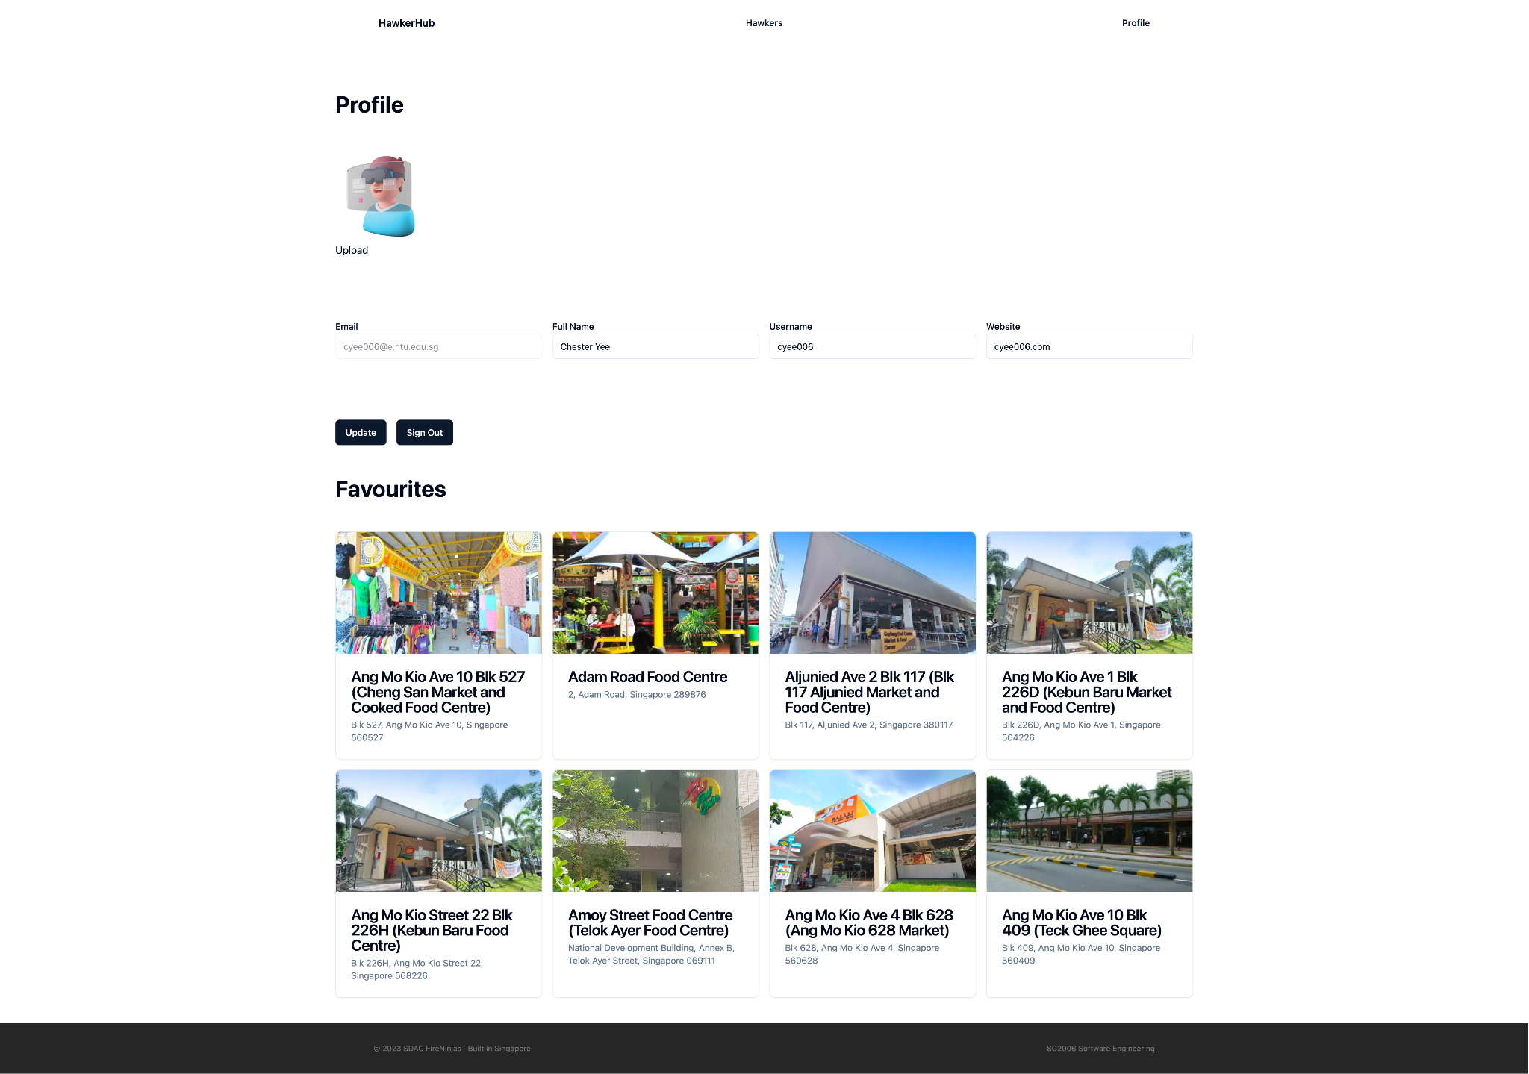

### Updated Profile Page

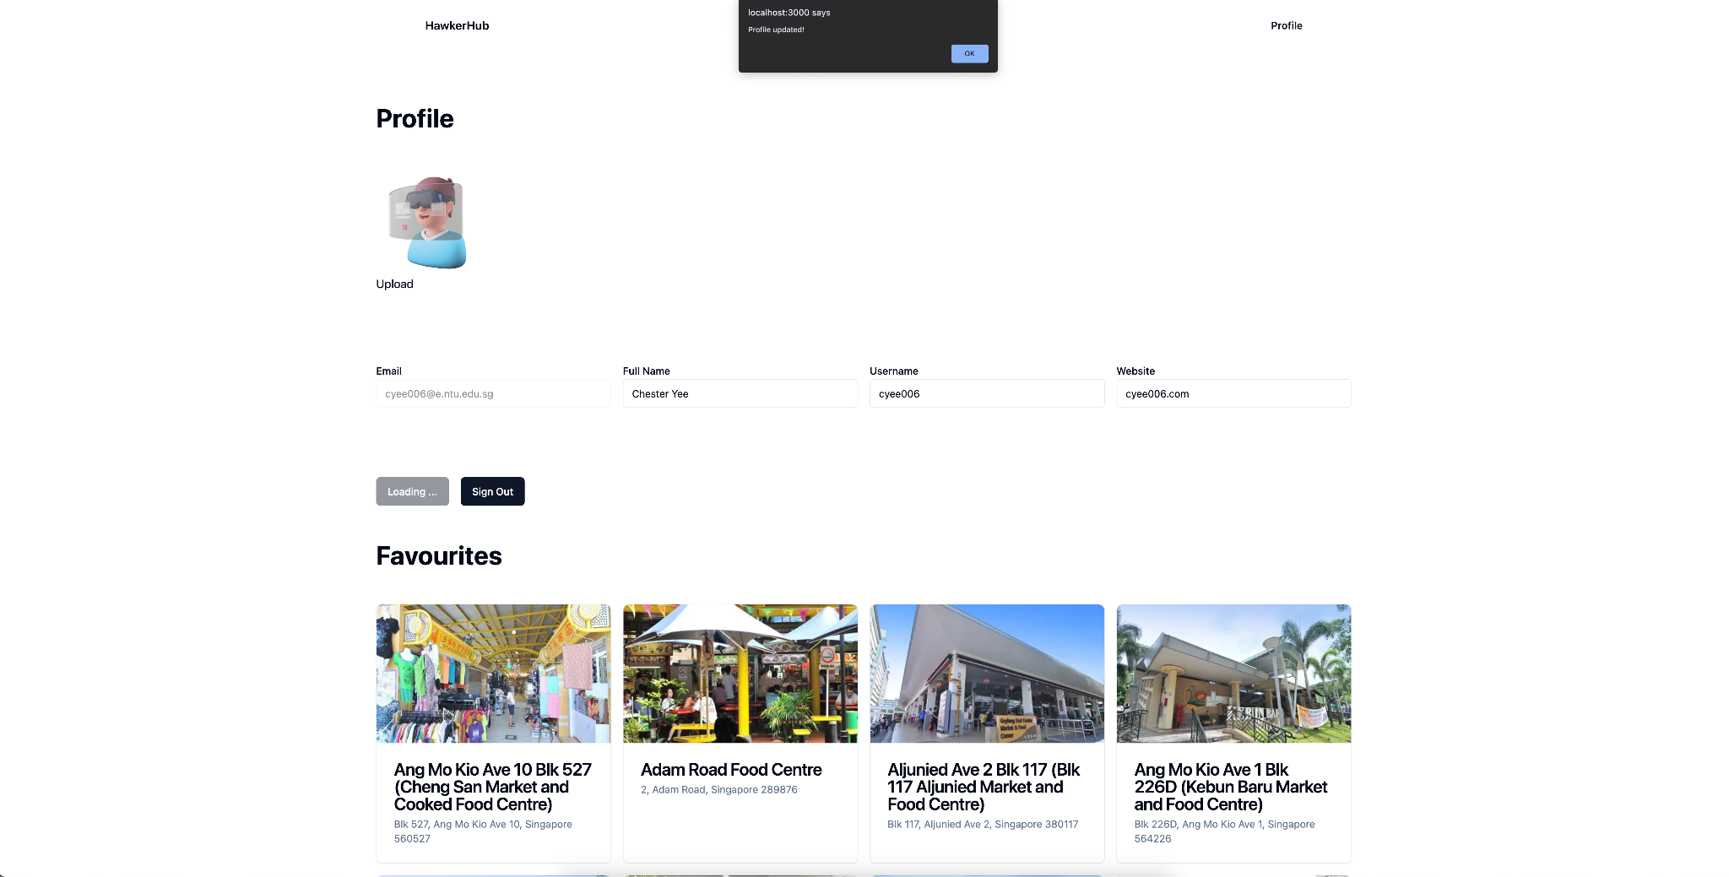

### HawkerList Page – Favorited

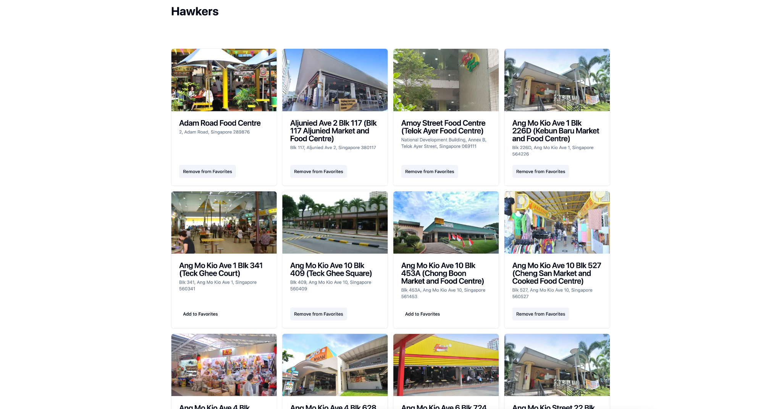

## Hardware Interfaces

This section covers all hardware interface requirements for HawkerHub to achieve its desired functionalities. The requirements can be streamlined into client-side and server-side to help the respective stakeholders achieve their desired goal.

### 3.2.1 Client-side Requirements

HawkerHub supports all desktop and mobile platforms. The device must have a web browser that can support HTML, CSS and JavaScript. Additionally, the device must have a stable internet connection in order to transmit and receive data from the server.

### 3.2.2 Server-side Requirements

The HawkerHub back-end server must be hosted and run on a server-computer. The back-end server will perform Create, Read, Update, Delete (CRUD) operations on the back-end database. The database must be hosted and run on a server-computer in the cloud.

## Software Interfaces

### 3.3.1 Software Components and Versions

HawkerHub is a web application that utilises a back-end server and database to handle data storage and authentication services required in the system features. The back-end server and database is built and implemented primarily using Supabase. The front-end is implemented using Next.js with the application router paradigm that uses Server-Side Rendering (SSR). Pages are rendered on the server side rather than the client side which brings several advantages, including improved performance, faster page loads, and better search engine optimization (SEO). When a user requests a page, the server generates the HTML content dynamically, including any data needed, before sending it to the client.

### 3.3.2 Software Architecture

HawkerHub is based on the Model-View-Controller (MVC) architectural pattern that can organise the software components and ensure a separation of concerns. The MVC pattern helps to structure the codebase, making it more modular, scalable, and maintainable.

The model layer represents the data and business logic of the application. For HawkerHub, the model would include components responsible for managing data related to hawker centres, user profiles, reviews and other relevant information.This layer can interact with APIs to fetch and update data and encapsulates the logic for data manipulation, validation and storage.

The view layer is responsible for presenting the data to the users and receiving their input. The layer includes components related to the user interface, such as pages, components, and templates for displaying information about hawker centres, photos and reviews. It should be designed to be responsive and user-friendly, ensuring a positive experience for users interacting with the application.

The controller layer acts as an intermediary between the model layer and the view layer. HawkerHub uses the controller layer to handle user input, processes requests, and updates the model layer accordingly. It receives input from the user interface, invokes the appropriate methods in the model layer to perform the necessary actions, and updates the view layer to reflect the changes.

## Communications Interfaces

The hawkerHub web application communication architecture must follow a client-server model. HawkerHub will communicate with the DataGovSG API, Supabase API, Google Places API, OpenAI API and Mapbox API using HTTPS protocol to ensure data security during transmission. Requests and responses will be in JSON format, following RESTful conventions. Before any request is made, all the APIs need to be initialised with an API key first to access the service securely.

DataGovSG API is used to fetch the dates of the hawker closure dataset. Supabase API performs operations on the fetching of user profiles and favourite stall details. Mapbox API performs operations to fetch map and geocoding information. Google Places API performs operations to fetch reviews, photos and opening hours. OpenAI Chat Completion API is used to perform sentiment analysis on the reviews retrieved from Google Places API to provide the user a brief summary of the hawker.

# System Features

System will perform its functionalities based on the Use Case Diagram and Sequence Diagram.

Refer Appendix B: Analysis Models to view how functionalities of the system interact with its users.

## Login to Application

### Description and Priority

Users log into the application using their own account.

High Priority: Users must log into the application to utilise personalised functionalities of the app.

### Stimulus/Response Sequences

| Flow of Events: | 1. User launches app. 2. User clicks on “sign- in” 3. User enters email 4. Application generates magic link in users email 5. User clicks link to log in |
| --- | --- |
| Alternative Flows: | AF-S2: User clicks on “sign up”   1. Application will redirect to 4.2 Create Account to register new user 2. Return to Step 2   AF-S3: User enters invalid email(not in the database)   1. Application will display an error message, prompting the use to enter a correct email 2. Return to Step 3 |

### Functional Requirements

1. User must be able to login using their own Account
   1. When the user logins, their email must be provided
      1. If an invalid email is provided, an error message is given, prompting the user to enter a correct email
   2. The system must verify that the provided email is correct
      1. The email provided must match to existing user details in the database

## Create Account

### Description and Priority

Users register for an account with their email.

High Priority: Required for using the Application to cater to specific needs of different individuals

### Stimulus/Response Sequences

| Flow of Events: | 1. User clicks on the “Sign-up” button to create an account. 2. The user will be redirected to another page to register for an account. Users will be required to enter account information(username, email address) 3. An verification email will be sent to the user. |
| --- | --- |
| Alternative Flows: | AF-S1: If user try to register an already registered account  A message will be displayed stating that the account is already registered  Application returns to step 2. |

### Functional Requirements

1. User must be able to register for a new account using the sign-up page
   1. When the user registers, their email and username must be provided
      1. The system must verify the email address provided is valid
      2. The system must verify if the email address is in the database
         1. If the email address is in the database, the user is prompted to use another email

## View Hawker Centres List

### Description and Priority

The user will be shown a search menu that lists Hawker Centres in separate cards.

Information(name, location, favourite status) will be displayed in each card for each Hawker Centre.

High Priority: It displays critical summarised information that allows the user to make fast comparisons and help him/her to decide on which to select.

### Stimulus/Response Sequences

| Flow of Events: | 1. User clicks on the “Hawkers” page 2. The application will generate the search menu 3. User can search for Hawker Centre based on keywords (4.4) 4. User can click on the Hawker Centre card to bring up the respective details page (4.10) |
| --- | --- |
| Alternative Flows: | AF-S4: User clicks on “Add to Favourite”  Application jumps to 4.7 Manage Favourite Hawker Center  Application returns to step 4 |

### Functional Requirements

1. The system must display a list of all available Hawker Centres in their respective cards
   1. Users must be able to scroll through the list
   2. Users must be able to search through the list using the search bar and relevant keywords
2. The system must allow users to access any Hawker Centres Details Page
3. The system must allow users to add Hawker Centres to their Favourites
   1. The system must allow user to remove Hawker Centres from their Favourites

## Search for Hawker Centres

### Description and Priority

Users will be able to type in keywords to search for relevant Hawker Centres.

High Priority: Required to filter through the Hawker Centre List

### Stimulus/Response Sequences

| Flow of Events: | 1. User clicks on the search bar. 2. User types in the keyword 3. If results are found, the search results will be displayed accordingly from highest to lowest rating. 4. If no results are found, a message will be displayed stating nothing was found |
| --- | --- |
| Alternative Flows: | - |

### Functional Requirements

1. Users must be able to search for Hawker Centres
   1. Users must input keywords into the search bar to facilitate the search
   2. System must filter the Hawker Centre List based on the keywords given
      1. System must display the filtered Hawker Centres List back to the User
      2. System must display warning message if no result scan be returned

## View Map

### Description and Priority

Users would be able to view the locations of Hawker Centres on the visual map. High Priority: Map facilitates Users planning out their Hawker Centre visits

### Stimulus/Response Sequences

| Flow of Events: | 1. User clicks on the “Hawkers” page 2. Application retrieves coordinates from MapBox API. 3. Drop pins will appear on the map indicating the Eateries. 4. User can click on the drop pin to bring up the respective details page (4.10) |
| --- | --- |
| Alternative Flows: | AF-S4: User clicks on “Nearby Location”   1. Application jumps to 4.11 View Nearby Hawker Centres 2. Application returns to step 4 |

### Functional Requirements

1. System must provide users with an interactive map that displays the locations of Hawker Centres
2. Map must be able to shrink down around User’s location
3. User must be able to access any Hawker Centres Details from the Map

## View Maintenance Table

### Description and Priority

Users can view a table of Hawker Centres maintenance dates.

High Priority: Table facilitates User planning out their Hawker Centre visits

### Stimulus/Response Sequences

| Flow of Events: | 1. Application retrieves data from API 2. Data is processed into table 3. Table is displayed on homepage, under “Closure Dates” 4. User views table and notes down the information 5. If the user clicks on a column, table will be sorted based on the data in that column 6. If the user clicks on “Columns”, the user is able to filter out specific columns to display, based on their own preferences 7. If the user types into the search bar, Application filters the table based on the search |
| --- | --- |
| Alternative Flows: | AF-S2: If any of user favourites is processed into table   1. Application jumps to 4.9 Upcoming Maintenance Notification 2. Return to step 2 |

### Functional Requirements

1. Users must be able to view a list of Hawker Centres maintenance dates
   1. System must retrieve data from API and process the data into a table
      1. Table must be displayed to Users
      2. Table must be able to be sorted and filtered based on user preferences
      3. If any of the Users Favourites has been processed, the System will notify the User

## Manage Favourite Hawker Centers

### Description and Priority

Users will be able to favourite or un-favourite their favoured hawker centres.

High Priority: Favoriting Hawker Centres is required in order to let users know when their Favourite Hawker Centres have maintenance.

### Stimulus/Response Sequences

| Flow of Events: | 1. User views the informational card of a specific Hawker Centre 2. User clicks on “Add to Favourite” 3. Application adds the Hawker Centre to the users list of favourites 4. “Add to Favourite” button changes to “Remove from Favourite” 5. User can now click on “Remove from Favourite” to undo the previous actions |
| --- | --- |
| Alternative Flows: | - |

### Functional Requirements

1. Users must be able to Favourite their preferred Hawker Centres
2. System must ensure Users are logged in before they can Favourite a Hawker Centre

## View Favorited Hawker Centres

### Description and Priority

Users will be able to view their favourite selections.

High Priority: Users are able to see all their Favourites in one place.

### Stimulus/Response Sequences

| Flow of Events: | 1. Application lists out favourite hawker centres in alphabetical order 2. In the list, Application will display the respective Hawker Centre Cards |
| --- | --- |
| Alternative Flows: | - |

### Functional Requirements

1. The user must be able to view all of their current Favourite Hawker Centres

## Upcoming Maintenance Notification

### Description and Priority

Application sends a notification when the user's favourite Hawker Centres have upcoming maintenance.

HIgh priority: Provides for personalised aspects of the app.

### Stimulus/Response Sequences

| Flow of Events: | 1. Application checks if there are any upcoming maintenance in the maintenance table 2. If there are upcoming maintenances, application checks if any of them are favorited by user 3. If there is a match, user is notified through their email that their favourite hawker centres have an upcoming maintenance |
| --- | --- |
| Alternative Flows: | - |

### Functional Requirements

1. Application must notify User of their favourite hawker centres having upcoming maintenance

## View Hawker Details

### Description and Priority

Users can view further details about a specific Hawker Centre that are not displayed in the information card.

High Priority: Application must provide the details of the hawker centres so that users can use these details to plan out their routes or to know more information about the hawker centre before going to visit them

### Stimulus/Response Sequences

| Flow of Events: | 1. User clicks on the information card 2. Application will pull reviews from Google Places API 3. Application will pass reviews into OpenAI API to obtain sentimental analysis of hawker centre 4. User will be brought to the details page for the selected Hawker Centre    1. Application will display a short description about Hawker Centre    2. Application will display Cleaning dates according to quarters    3. Application will display overall sentiment of hawker centre    4. Application will display number of food stores    5. Application will display number of market stores    6. Application will display a map showing location of Hawker Centre    7. Application will display reviews of the Hawker Centre |
| --- | --- |
| Alternative Flows: | - |

### Functional Requirements

1. User must be able to view more details of a selected Hawker Centre
   1. Details include: reviews, sentiment analysis, description, number of stores of each type

## View Nearby Hawker Centres

### Description and Priority

Finds nearby Hawker Centres to users location.

Medium Priority: Allows for convenience of users when locating hawker centres on the map

### Stimulus/Response Sequences

| Flow of Events: | 1. While User is viewing the map, he clicks on “ Nearby Location” 2. Application requests for users location 3. User accepts the request 4. Application locates all hawker centres nearby Users location 5. Application zooms in on the Map to the Users location and displays nearby hawker centres as dropped pins |
| --- | --- |
| Alternative Flows: | - |

### 

### Functional Requirements

1. Users must be able to view nearby hawker centres within a 2km radius of their location

## Update Account Details

### Description and Priority

User can change their account details.

High Priority: Ensures that user’s details are kept up to date

### Stimulus/Response Sequences

| Flow of Events: | 1. At account page, user clicks on details they wish to edit 2. User types in their changes 3. User clicks on “Update” button 4. Application reads in changes into the database |
| --- | --- |
| Alternative Flows: | - |

### Functional Requirements

1. Application must ensure that it is able to allow users to update their details in a secure and easily accessible manner
2. Application must propagate changes to the database without issue

## View Account

### Description and Priority

Users can view their account to ensure all their details are correct and to easily access their favourites list of hawker centres.

Medium Priority: Provides for a user friendly experience

### Stimulus/Response Sequences

| Flow of Events: | 1. User clicks on “Profile” 2. Application loads in the users account page along with their details 3. Application displays users’ list of Favourited Hawker Centres (UC008) 4. If the user clicks on “Sign out”, the Application will sign them out of their account and exit the profile page. |
| --- | --- |
| Alternative Flows: | AF-S2: User clicks on a detail   1. Application jumps to UC012 Update Account Details 2. Return to step 2 |

### Functional Requirements

1. Users must be able to view their own account
   1. User Accounts must display their account information:
   2. User Accounts must display a list of the Users Favourite Hawker Centres
2. Users must be able to sign out of their Account

# Other Nonfunctional Requirements

## Performance Requirements

1. The initial page load must not be more than 10 seconds
2. Application must be able to respond to the user's input within 5 seconds
3. Application must ensure that the correct items are returned to the user based on the searched keywords

## Safety Requirements

1. System must use strong authentication method
2. Login/logout system must be kept up to date with latest security patches

## Security Requirements

1. System must send email verification to registered email when signing up
2. System must send email to users for them to log in
3. System must ensure the user is logged in prior to favoriting any Hawker Centres
4. Users must be logged in using their registered email.

## Software Quality Attributes

### 5.4.1 Availability

1. The web application must have an uptime of 99.5% of any calendar month, excluding scheduled maintenances

### 5.4.2 Adaptability

1. The system will integrate any new technologies that can improve user experience within two weeks of receiving API documentation and resources

### 5.4.3 Maintainability

1. Maintenance tasks such as security updates must be completed within 24 hours of release

### 5.4.4 Portability

1. Web application must be compatible with latest versions of all browser types on any device

### 5.4.5 Reliability

1. System must have a mean time between failures of at least 30 days
2. System must have a maximum downtime of 4 hours for critical failures

### 5.4.6 Reusability

1. At least 60% of codebase must be designed to be as reusable as possible for integration into future projects

### 5.4.7 Testability

1. System must be able to run a comprehensive set of automated tests which covers at least 90% of codebase within 1 hour whenever any changes are made to the codebase

### 5.4.8 Robustness

1. Web application must be able to handle unexpected inputs properly, providing users with informative error messages and maintaining functionality

### 5.4.9 Usability

1. System must achieve a task success rate of 95% when completing common tasks (eg. favoriting/unfavoriting hawker centre, searching for hawker centres)
2. Web applications must return relevant results with an accuracy of at least 95% when using a searching feature. Relevance is determined based on keywords, popularity and user preferences.
3. System must correctly handle concurrent access by multiple users and ensure no data corruption or inconsistency

## Business Rules

### 5.5.1 User Authentication

Rule: Only registered users with a valid email account can log in to the web application

Implication: A secure user registration and authentication system must be implemented

### 5.5.2 Favourite Hawker Centres

Rule: Users can mark hawker centres as favourites only if they are logged into their account

Implication: Must implement a feature that allows users to add/remove hawker centres from favourites list

### 5.5.3 Update Account

Rule: Users can edit their profiles to update personal information (eg. name, email, profile picture)

Implication: Ensure that only authenticated users have access to account management features

### 

### 5.5.4 Maintenance Table

Rule: Users with or without an account can access maintenance table

Implication: Not necessary to log in in order to utilise this feature

### 5.5.6 Notification Preference

Rule: Users with an account can customise notification preferences based on their favourite list

Implication: Must develop a notification system and a secure account system

### 5.5.7 Magic Link Authentication

Rule: Users must login by using a magic link sent to their registered email address

Implication: Must implement a secure magic link authentication feature

### 5.5.8 Nearby Hawker Centres

Rule: Users with or without an account must grant location access in order to find nearby hawker centres

Implication: Implement geolocation services and seek user consent to get coordinates in order to find nearby hawker centres. Not necessary to log in in order to utilise this feature

### 5.5.9 View List of Hawker Centres

Rule: Users with or without an account can access list of hawker centres

Implication: Not necessary to log in in order to utilise this feature

### 5.5.10 View Map

Rule: Users with or without an account can access map in HawkerHub

Implication: Not necessary to log in in order to utilise this feature

### 5.5.11 View Hawker Centre Details

Rule: Users with or without an account can access map in HawkerHub

Implication: Not necessary to log in in order to utilise this feature

# Other Requirements

## Appendix A: Data Dictionary

| **Term** | **Definition** |
| --- | --- |
| User | Person who is using our application to view hawker centres in Singapore |
| System/Application | Web application |
| Account | Personal profile for each user that they have to register for. Holds personal information of the User. Required for: Favoriting Hawker Centres, Viewing and Updating the Account, Viewing Favorites Hawker Centres. |
| Page | Refers to the various pages that comprise the App: Main, Hawkers, Account, Hawker Centre Details. |
| Main Page | First page loaded by Application when accessed. |
| Hawkers Page | Accessed by clicking on “Hawkers” from the Main page. Displays the Upcoming Maintenance Table. |
| Upcoming Maintenance Table | A Table containing the names of Hawker Centres that have upcoming(within 2 weeks) maintenance and their corresponding dates. |
| Hawker Centre Maintenance | Every Hawker Centre goes through a regulatory maintenance period once every quarter. Dates are pulled from API. |
| Hawker Centre Table | A table(displayed on the Main page) containing the information pulled from the API, can be filtered using its columns. |
| Profile Page | Accessed by clicking on “Profile” from the Main page. Displays the Users Account Details and Favourited Hawker Centres. |
| Favourite Hawker Centres | Hawker Centres that have been Favourited are compiled into a list and displayed on the users’ Account. |
| Hawker Centre  Details Page | Accessed by clicking on a Hawker Centre card from the Hawkers page. Displays more information( all maintenance dates) pulled from API |
| Hawker Centre | A market at which individual vendors sell ready-to-eat food from small booths. Locations pulled from the API |
| Visual Map | Map of Singapore displaying all the Hawker Centre locations. Displayed in the “Hawkers” page |
| Verification email | Sent to the User’s email post account-creation |
| Hawker Centre Cards | A small card that contains certain information(name, location, favourite status) about a specific Hawker Centre. Each different Hawker Centre has its own card, and all cards are arranged into a list (Search Menu). Clicking on the card redirects the user to the respective Hawker Centres Details Page. Clicking on “Favourite” will add the respective Hawker Centre to the users’ Favourite Hawker Centres |
| Search Menu | A list of Hawker Centre Cards displayed in the Hawkers Page. The menu can be searched through using the search bar |

## 

## Appendix B: Analysis Models

## 

Class Diagram

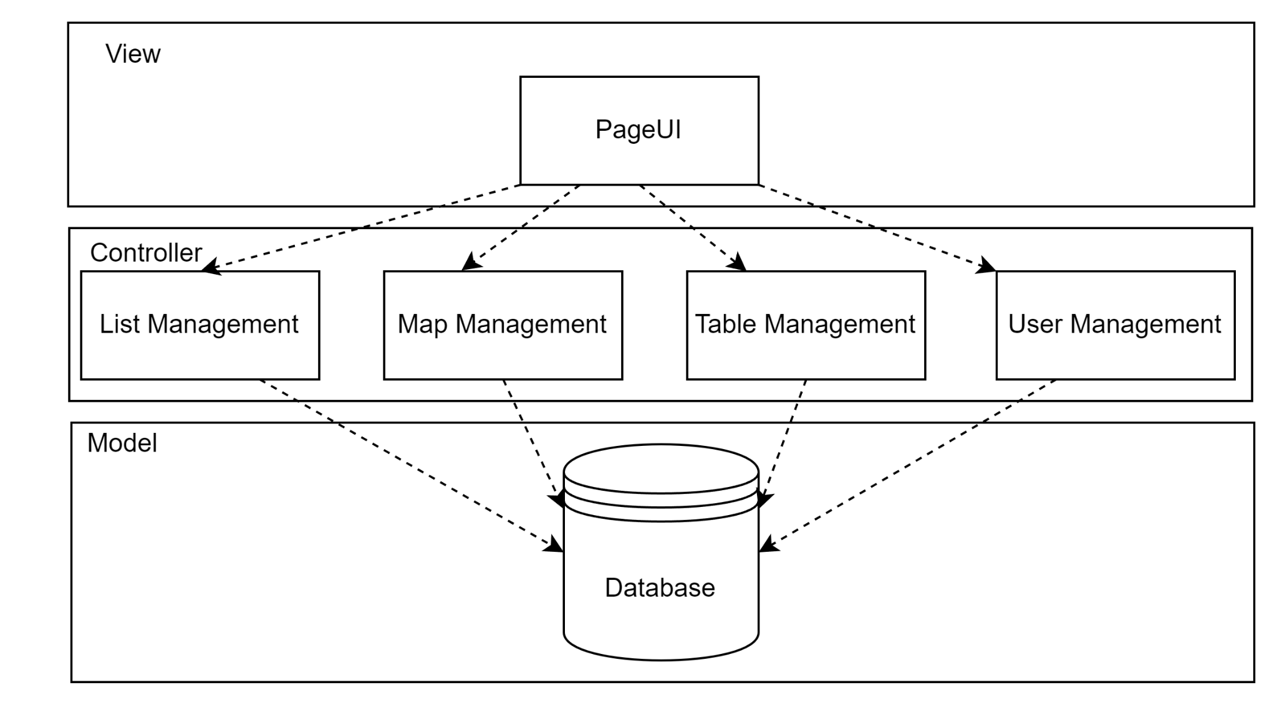System Architecture

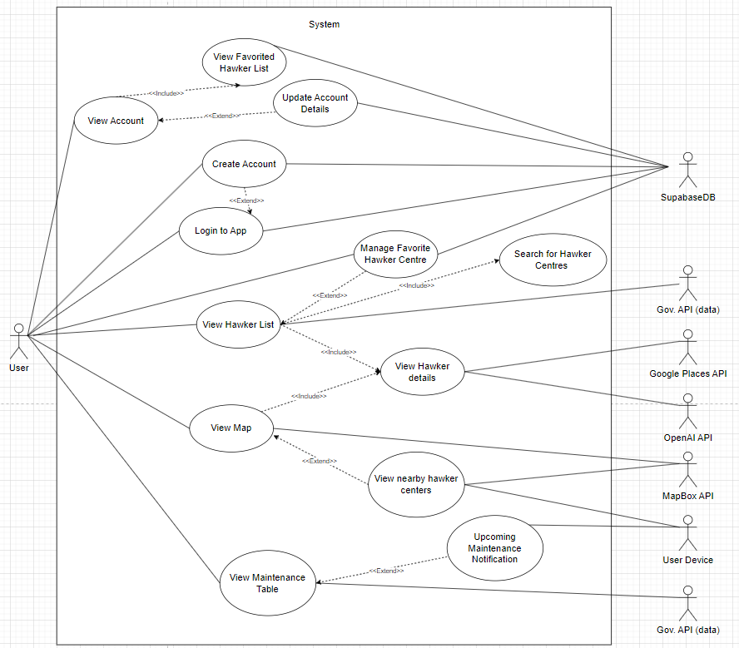

Use Case Diagram for Hawker Hub

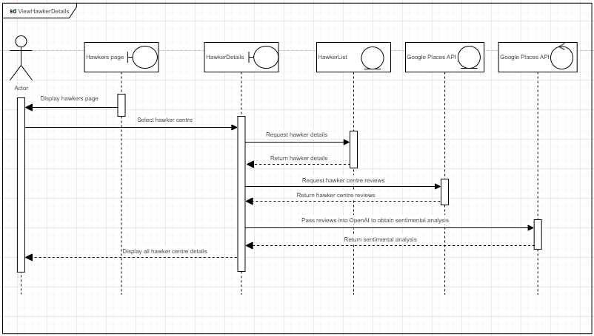

Sequence Diagram for View Hawker Details

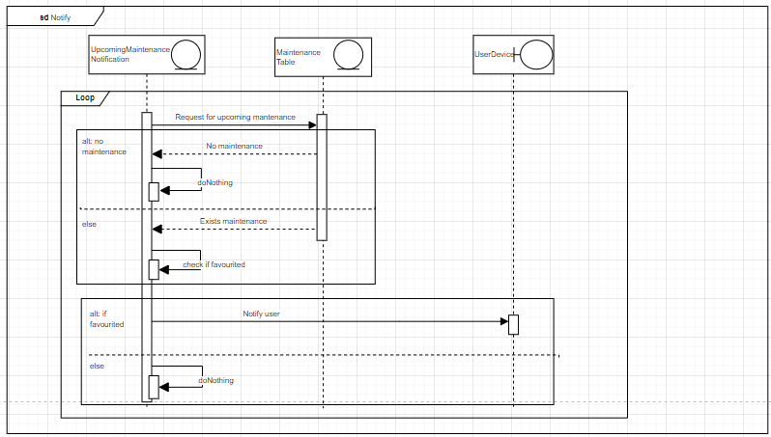

Sequence Diagram for Notify

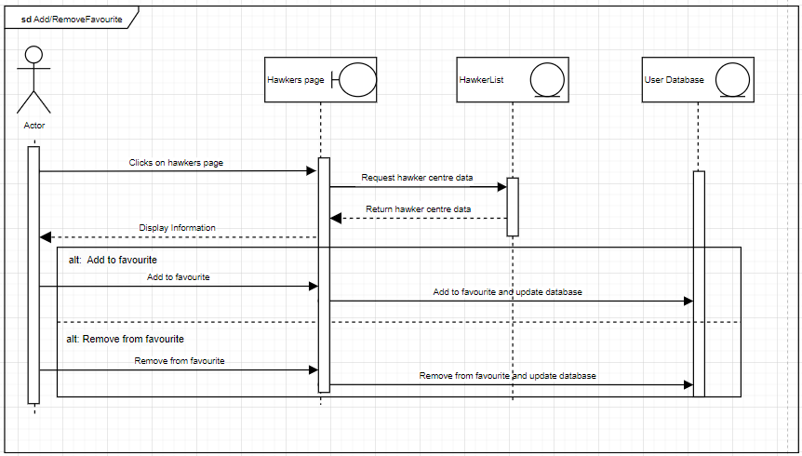

Sequence Diagram for Add Remove Favourite

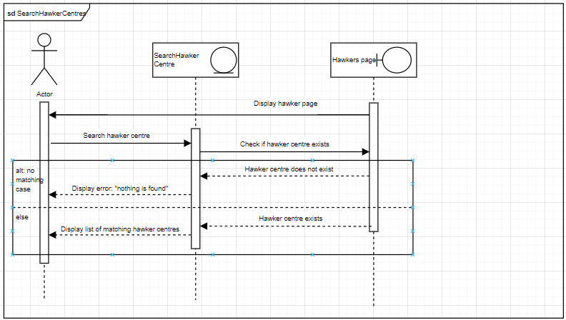

Sequence Diagram for Search Hawker Centre

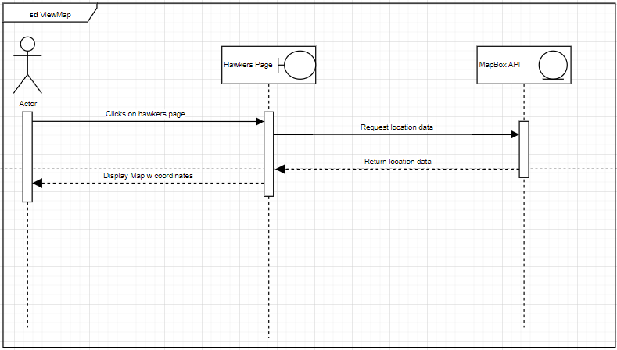

Sequence Diagram for View Map

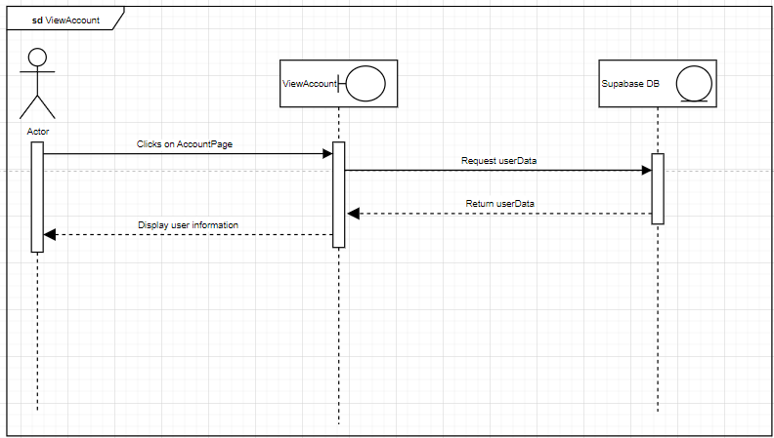

Sequence Diagram for View Account

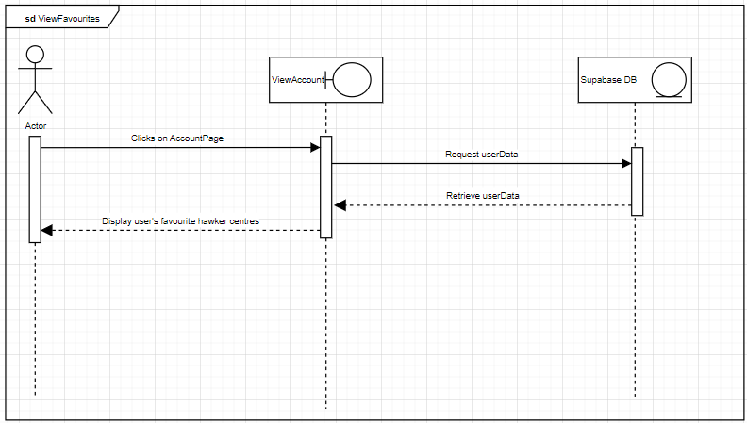

Sequence Diagram for View Favourite

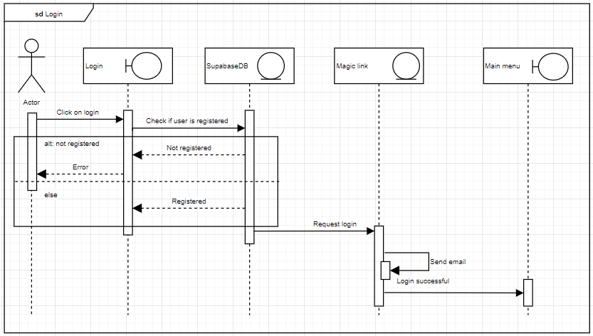

Sequence Diagram for Login

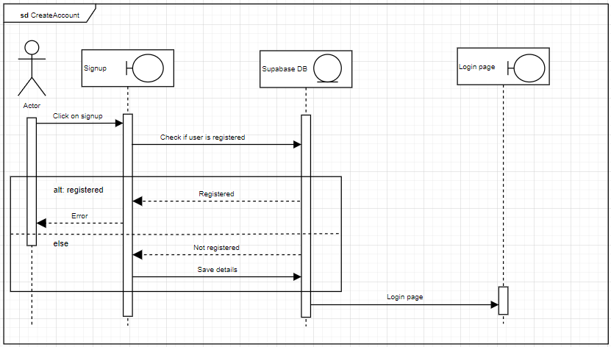

Sequence Diagram for Create Account

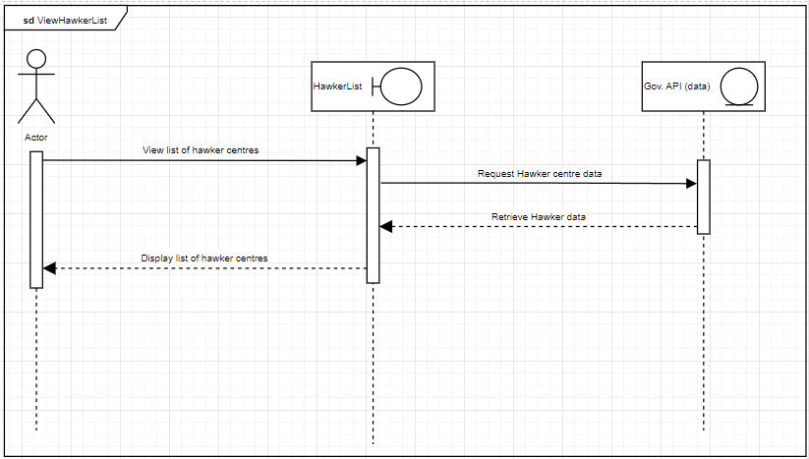

Sequence Diagram for View Hawker List

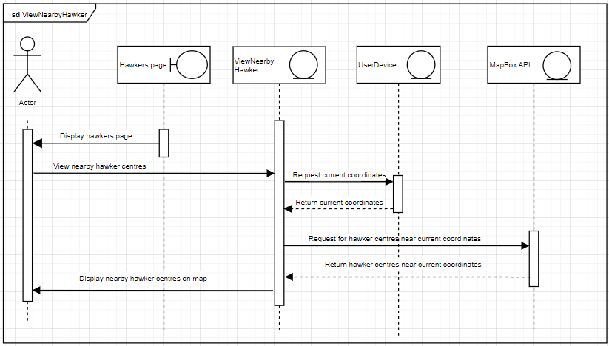

Sequence Diagram for View Nearby Hawker

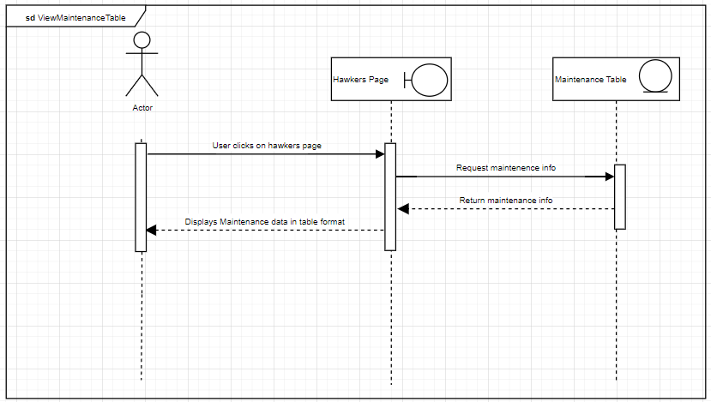

Sequence Diagram for View Maintenance Table

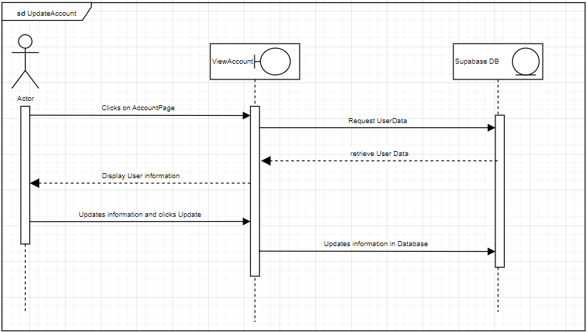

Sequence Diagram for Update Account

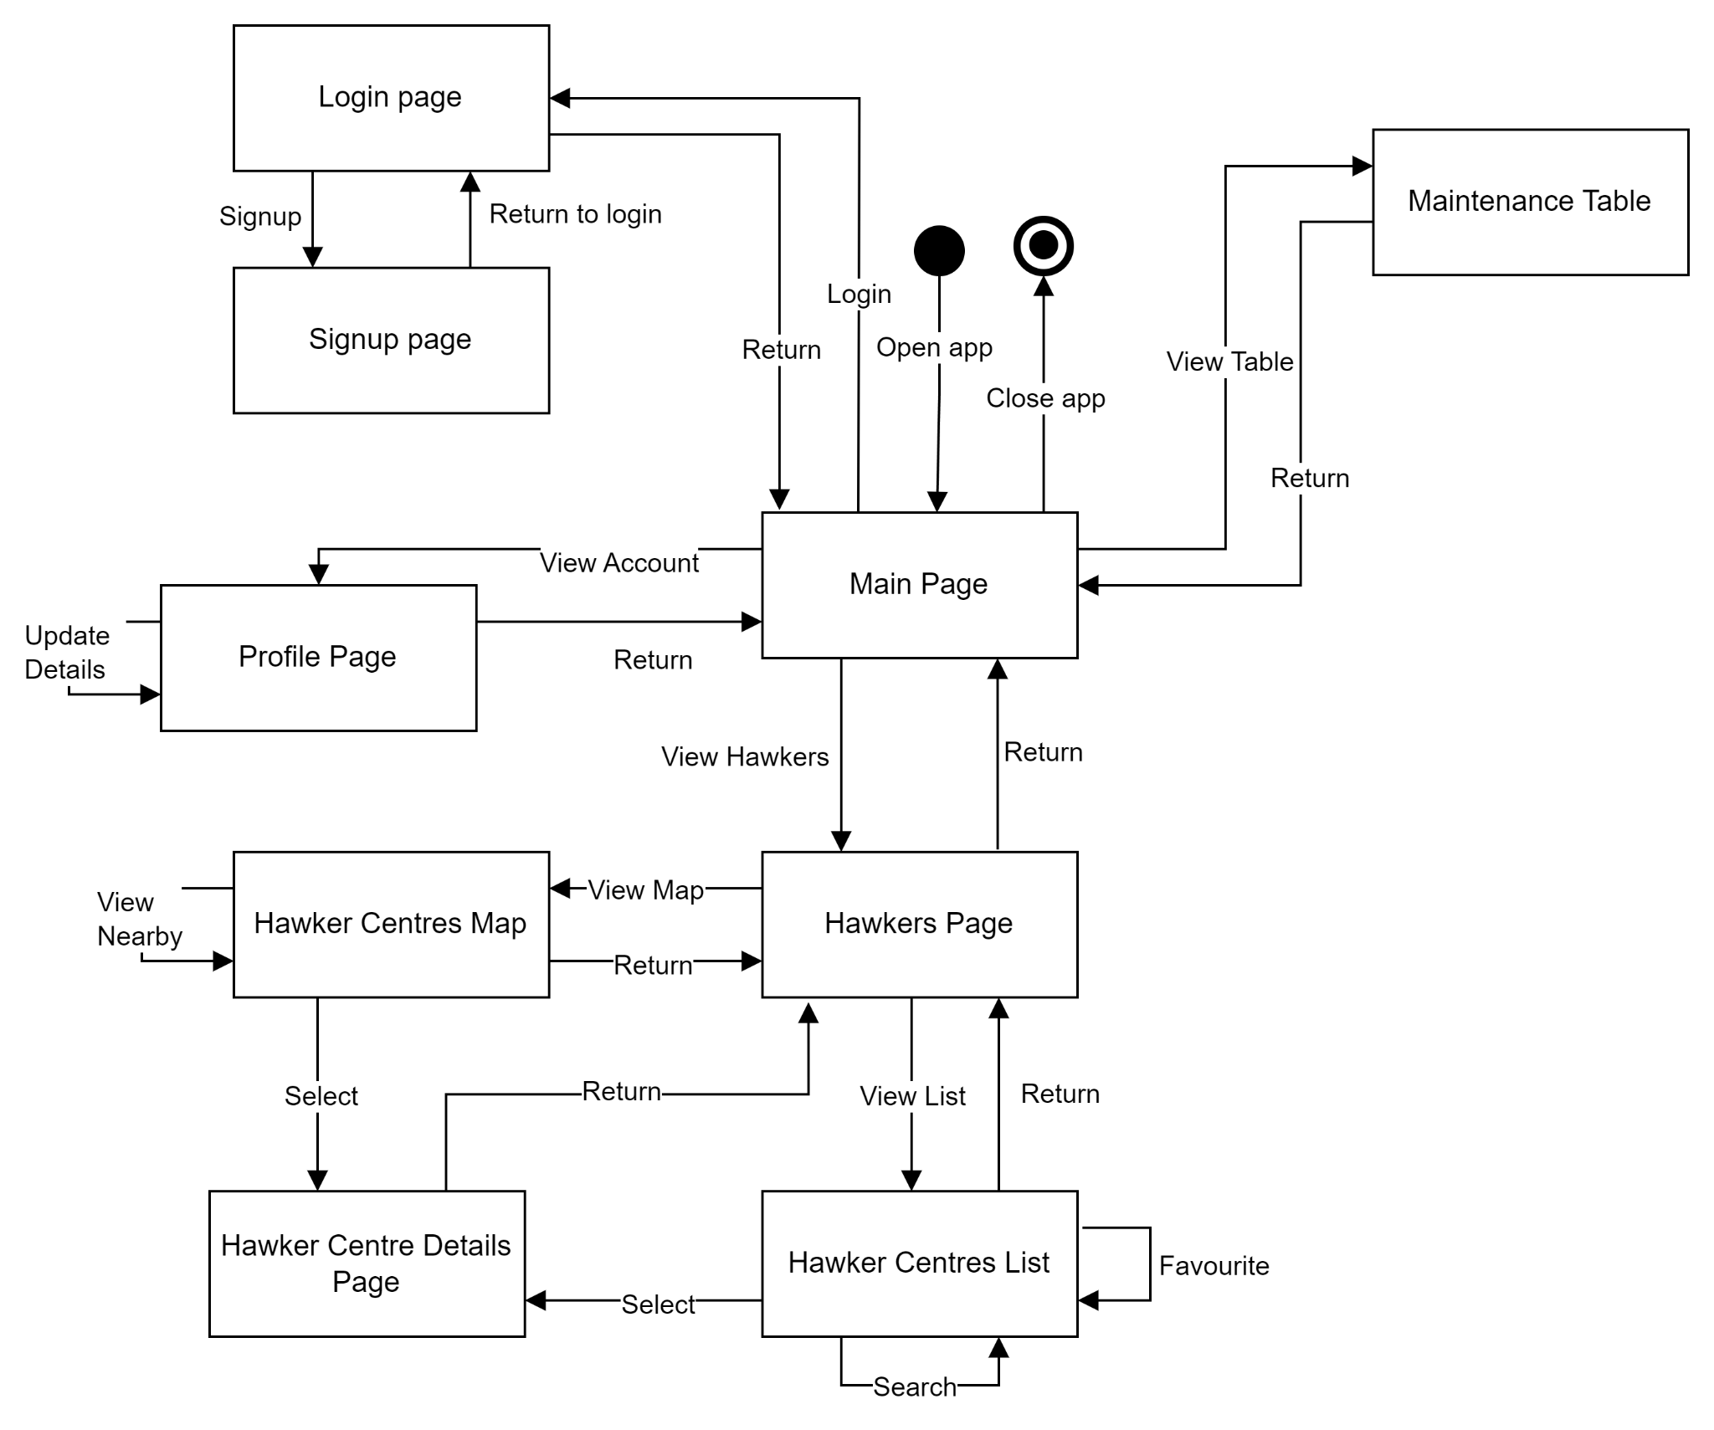

Dialog Map